**Measure of Location Placement Data**

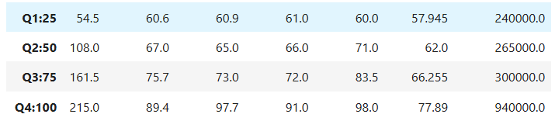

**Q1(25%):**

**sslc pass:** The 25% of value is between is 60.6

**hsc_p:** The 25% of value is between is 60.9

**degree_p:** The 25% of value is between is 61.0

**etest_p:** The 25% of value is between is 60.0

**mba_p:** The 25% of value is between is 57.945

**salary:** The 25% of value is between is 240000.00

**Q2(50%):**



**10thp:** The 50% of value is between is 60.6, the increase percentile is 7%

**hsc_p:** The 50% of value is between is 65.0, the increase percentile is 4%

**degree_p:** The 50% of value is between is 66.0, the increase percentile is 5%

**etest_p:** The 50% of value is between is 71.0, the increase percentile is 11%

**mba_p:** The 50% of value is between is 62.0, the increase percentile is 5%

**salary:** The 50% of value is between is 265000.0, the increase percentile is 25000

**Q3(75%):**



**10thp:** The 75% of value is between is 75.7, the increase percentile is 8%

**hsc_p:** The 75% of value is between is 73.0, the increase percentile is 8%

**degree_p:** The 75% of value is between is 72.0, the increase percentile is 6%

**etest_p:** The 75% of value is between is 83.5, the increase percentile is 12%

**mba_p:** The 75% of value is between is 66.255, the increase percentile is 4%

**salary:** The 75% of value is between is 300000, the increase percentile is 35000

**Q4(100%):**



**10thp:** The 100% of value is between is 89.4, the increase percentile is 14%

**hsc_p:** The 100% of value is between is 97.7, the increase percentile is 24%

**degree_p:** The 100% of value is between is 91.0, the increase percentile is 19%

**etest_p:** The 100% of value is between is 98.0, the increase percentile is 15%

**mba_p:** The 100% of value is between is 77.89, the increase percentile is 11%

**salary:** The 100% of value is between is 940000.0, the increase percentile is 640000